Flight Price Prediction

**Problem Definition:**

Flight ticket prices can be something hard to guess, today we might see a price, check out the price of the same flight tomorrow, it will be a different story. We might have often heard travellers saying that flight ticket prices are so unpredictable. Here we will be provided with prices of flight tickets for various airlines between the months of March and June of 2019 and between various cities.

Size of training set: 10683 records

Size of test set: 2671 records

FEATURES:

Airline: The name of the airline.

Date_of_Journey: The date of the journey

Source: The source from which the service begins.

Destination: The destination where the service ends.

Route: The route taken by the flight to reach the destination.

Dep_Time: The time when the journey starts from the source.

Arrival_Time: Time of arrival at the destination.

Duration: Total duration of the flight.

Total_Stops: Total stops between the source and destination.

Additional_Info: Additional information about the flight

Price: The price of the ticket

**Python Coding:**

First we will import the relevant libraries in python.

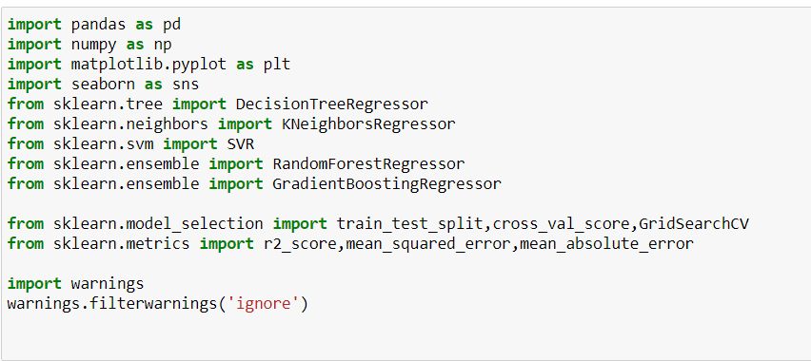

**Data Analysis:**

Here we are using two datasets - **train data** and **test data**

First we will work on the training dataset,

We can load the data directly from the GitHub. Here we are using pandas to load the data. Observe the following code, we are using this code to load the data.



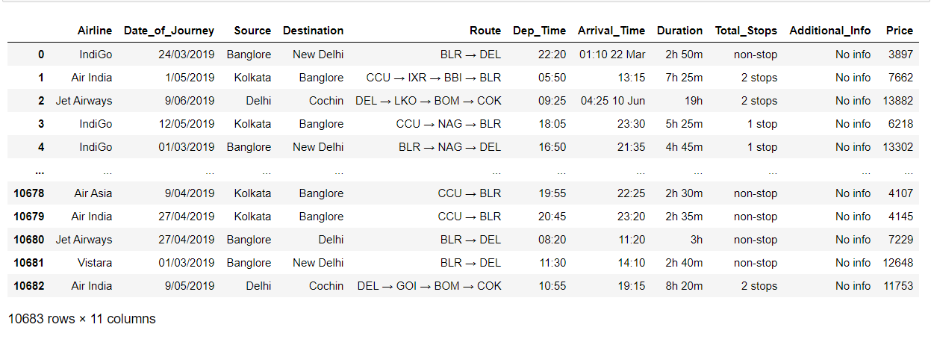

Training data is combination of both categorical and numerical, also we can see that some special characters are also being used so we have to do some data transformations on it before applying it to our model.

We are loading the **test dataset** using the code-

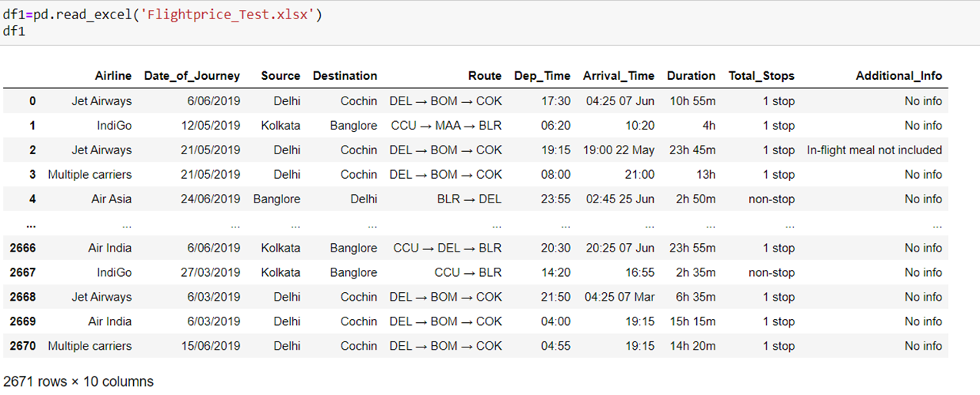

The test data is similar to the training data set, minus the ‘Price’ column (To be predicted using the model).

**Summarizing the dataset**

Summarizing the data can be done in many ways as follows −

* Checking the dimension of the dataset
* View the statistical summary of the attributes
* Check the datatypes of the dataset
* View the information regarding the dataset

Dimension of the train dataset :-

We can use the following command to check how many instances (rows) and attributes (columns) the data contains with the shape property.



The output is shown below-



We can see that there are 10683 rows and 11 columns in the train dataset.

Dimension of the train dataset:-

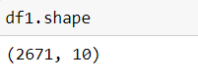

Test dataset contains 2671 rows and 10 columns

View the Statistical Summary :-

You can view the statistical summary of each attribute, which includes the count, unique, top and freq, by using the following command.

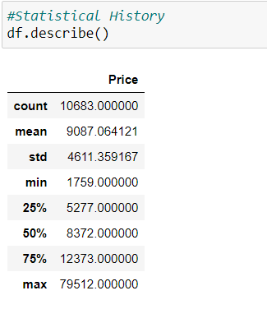

The Statistical Summary of the **Test dataset** is given below-

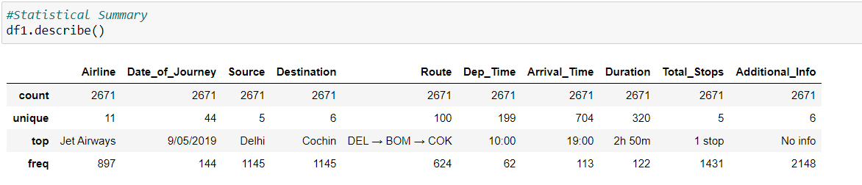

We will get the column list of the train dataset by using the command df.columns

The output is given below-

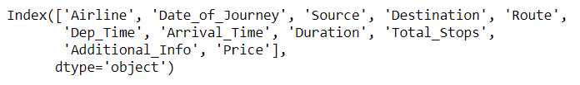

Checking datatypes :-

Before cleaning the data we have to check the datatypes of the each variable using the command df.dtypes

The output is shown below-

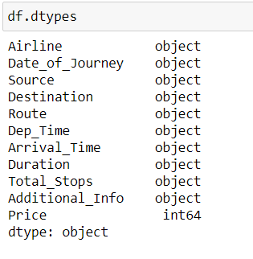

Here from the output it is clear that all the variables other than target variable “Price” is object type.

We will get the overall information regarding the dataset using the following command and the output is also given with that-

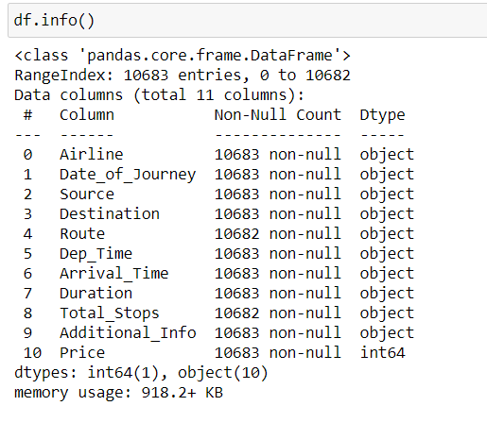

From the dataset information we can observe the null values and datatypes of variables etc.

**Test dataset** information:

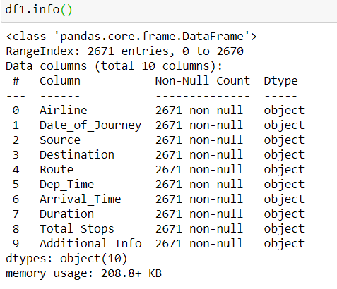

Checking null values :-

Now we will check the null values in the **train dataset** using the command



And the output is

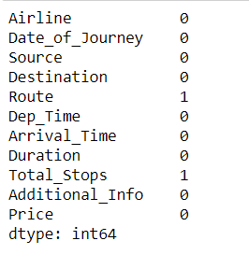

From this output it is clear that there is one missing value present in each variable **Route** and **Total_Stops.**

Checking the null values in the **test dataset**

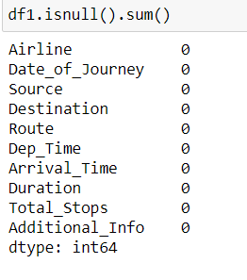

There is no null values in the test dataset

**The visualization of the null values using heatmap**

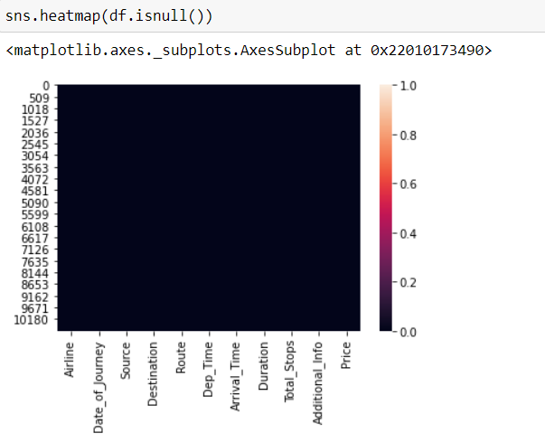

Since there is only one null value its not marked well. But this black color indicates the presence of null values .

**EDA Concluding Remarks:**

Data Visualization:-

We can visualize the data using two types of plots as shown −

* Univariate plots to understand each attribute.
* Bivariate plots to understand the relationship between two variables.
* Multivariate plots to understand the relationships between attributes.

Univariate Analysis:

Analysis of single variables.

Let’s have a look at the **Univariate analysis** of the train dataset-

Here we use for loop for the analysis of single variables.

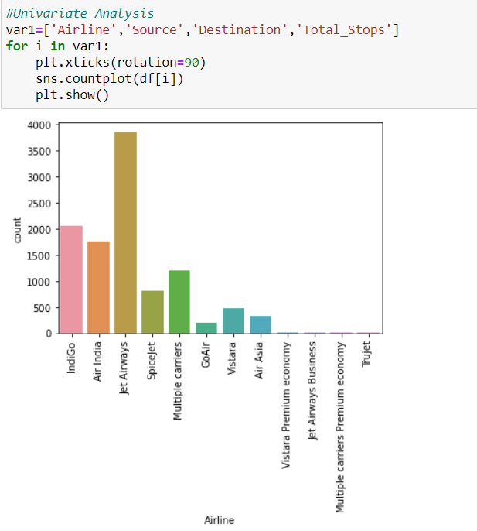

* The Airways "Jet Airways" comes out most of the time. Means most of the flight services are operated by Jet Airways.

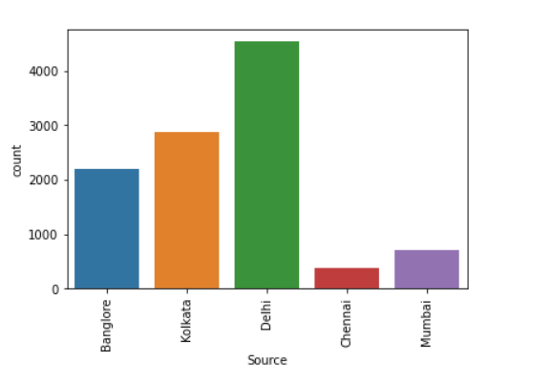

* For most of the flight services Delhi is the source. Second most services are operated from Kolkata. Flight services with Chennai as source is minimum in number.

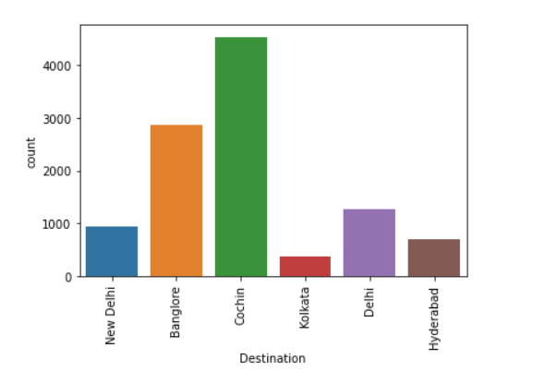

* For Maximum flight services destination is Cochin. For second most flight services Bangalore is the destination.

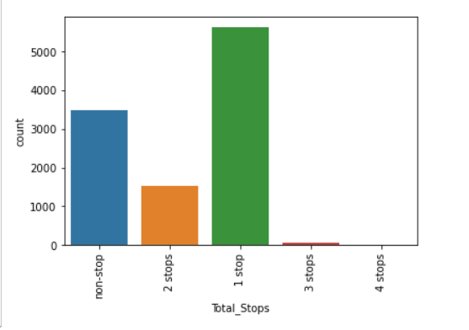

* For most of the fight operations there is only one stop. Second most services are non-stop

**Bivariate analysis:**

Analysis based on two variables.

The code we used is given below-

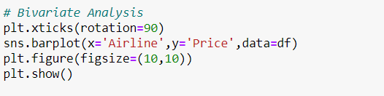

And the output is

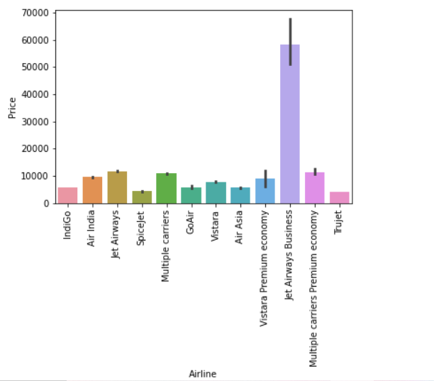

* Price is high for the airline Jet Airways Business.
* Jet Airways, Multiple Carriers, Multiple carriers premium economy price is above 10000.
* SpiceJet and Truejet have less price.

We plot a bar graph with x axis as Total_stops and y axis as Price

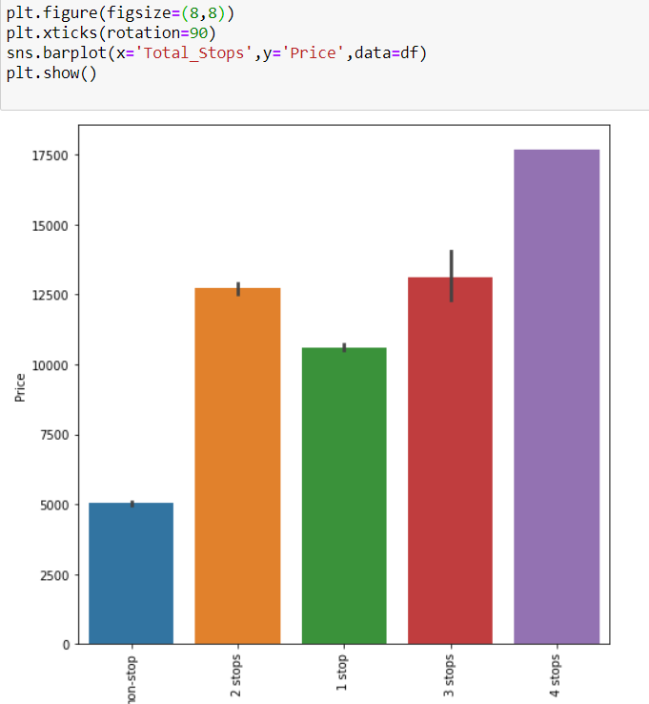

* From this we can observe that Airlines which have 4 stops have maximum price.
* Also we can observe that price is increasing with the number of stops.

Count plot of variables Airline and Total_Stops. We use the following code

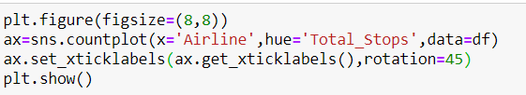

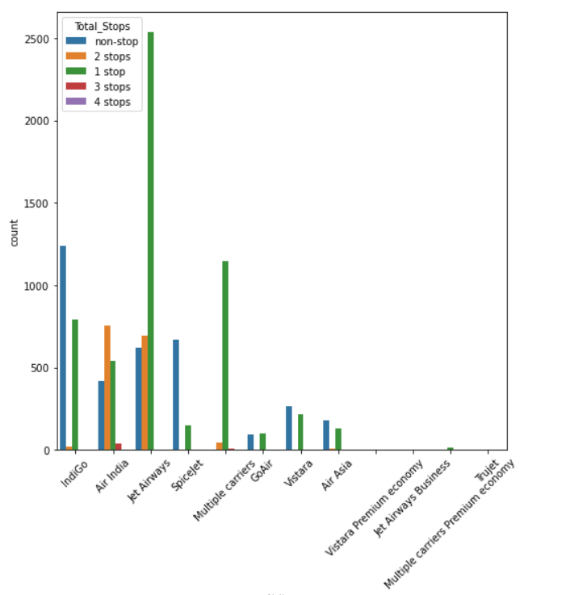

* Most of the airlines have non-stop and one stop.
* Among all airlines, most of the Jet Airways services have one stop.

We have plotted a bar graph with x axis as Journey_month y axis as Price

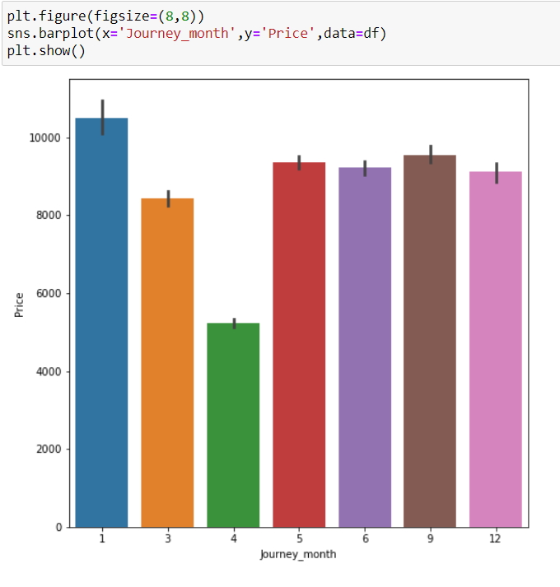

* Price is maximum in the month January.
* Price is minimum in the month April.

**Date_of_Journey**

In the column ‘Date_of_Journey’, we can see the date format is given as dd/mm/ yyyy and as you can see the datatype is given as object So there is two ways to tackle this column, either convert the column into Timestamp or divide the column into date, Month . Here , i am splitting the columns

Now we have to convert it into timestamp using pandas.to_datetime

First we will import datetime using the following code



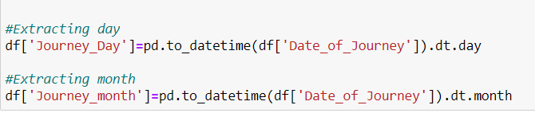

Using the above command, we will extract day and month from the Date column.

After extraction we will drop the column Date_of_Journey using the code shown below-



We will do the same in **test dataset**, the code used is given below-

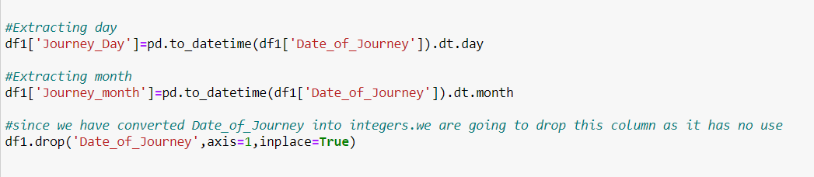

Similarly we will extract minute and hour from Dep_time of **Train dataset** using the following command

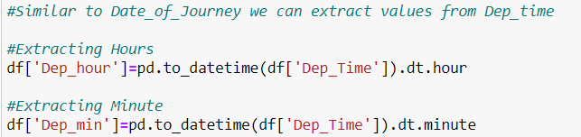

After extracting hour and minute fromDep_Time. we will drop the column Dep_Time using the code



Now we are using the same extraction in **test dataset**

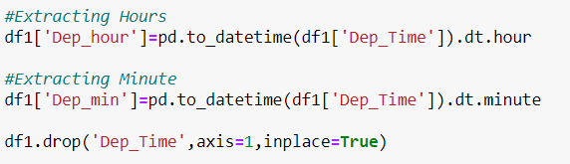

Now we are going to extract hour and minute from the column Arrival_Time in **train dataset** using the following code

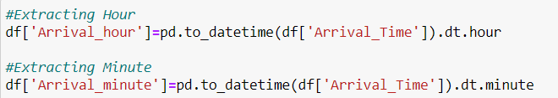

After extracting the required data we will drop the column Arrival_Time



Now will extract the same from the column Arrival_Time in **test data**

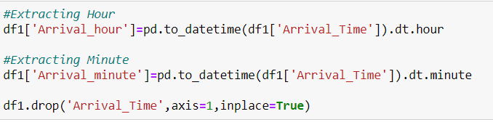

Now we will make a countplot setting x axis as Airline and y axis as Journey_month and we will use the following code-

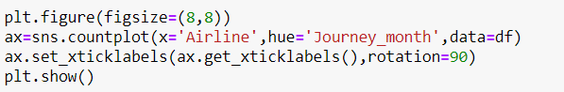

And out output is

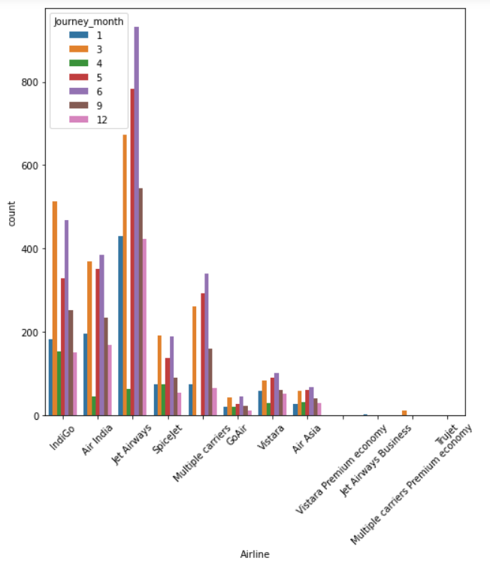

* From the data it is clear that most of the flight operations were done in the month May, March and June. among all airways Jet Airways travelled maximum.
* And second Airline which has done the journey most in the month June, May and March is Indigo.

We made an analysis by using a countplot in which we set x axis as Airline and y axis as Journey_day..and the code is given below-

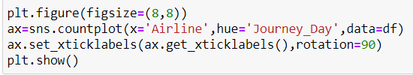

And the plot is given below

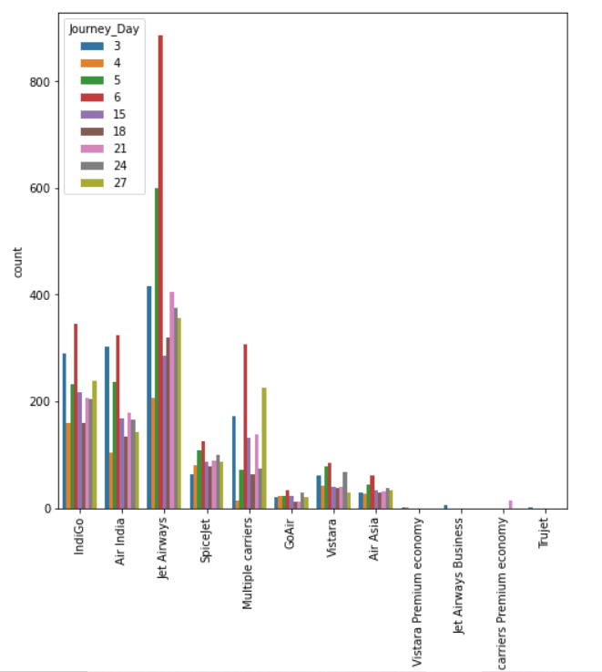

* Our conclusion from this graph is that for most of the Airlines flight operation is more in day 6.

Now we will plot a bar graph by setting x axis as Journey_month and y axis as Price

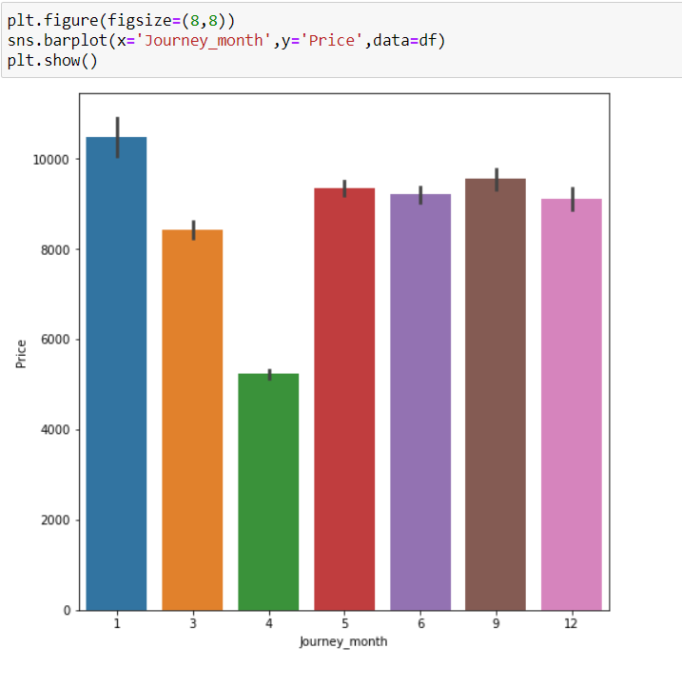

Conclusion from the graph-

* Price is maximum in the month January.
* Price is minimum in the month April.

**Multivariate Analysis**

Analysis of different variables.

Here we will check the correlation of variables using the following command-

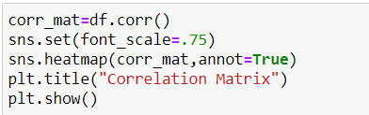

And the output is

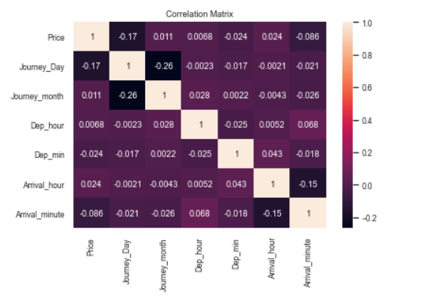

**Distribution of data**

In this dataset we are plotting only the distribution of target variable “Price”, since only Price is the continuous variable.

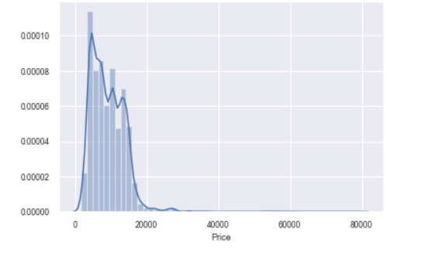

**Data Pre-processing:**

Data preprocessing is a data mining technique which is used to transform the raw data in a useful and efficient format.

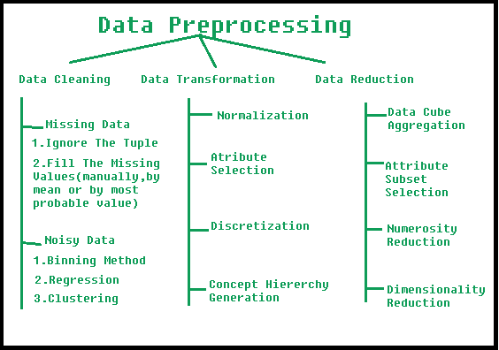

Replacing NaN values using SimpleImputer:

Now we are going to replace the NaN values in the columns of the dataset using the function SimpleImputer. If the NaN values remains in the data it will disturb our algorithm. So we have to remove it. For the categorical type variables we will replace null values using mode.

We will import SimpleImputer using the code shown below-



Then replace the null values from the columns Route and Total_Stops using the following code

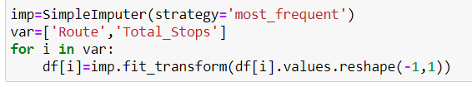

Now we removed the nan values.

Converting Categorical variables to Numerical:

Here we will use pandas.get_dummies, since our variables contains more class /labels.

We will use the following code



We will use mapping to Convert the variable Total_Stops to numerical



Now we are going to convert categorical variables into Numerical in **test dataset**

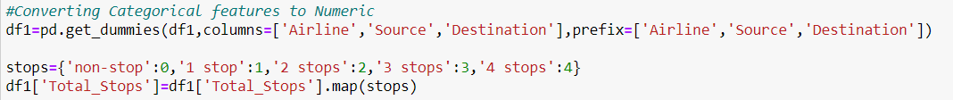

Removing Irrelevant columns:

Now we are going to drop some columns that are not so important

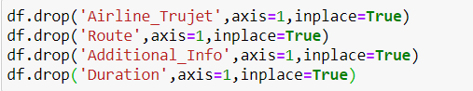

We will drop the same columns from the **test dataset**

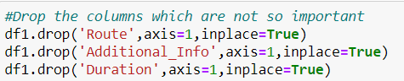

Separating Independent and Target variable as x and y:

Before building a machine learning model, data is always split into two different parts that are called Training and Testing. For the training purpose of the model, we only expose the training data and never allow testing data to be exposed. Once the model gets trained using that data, we make use of the model to compute the predictions over the testing data, which is stored in a single variable known as y_pred. We can store it in a different variable as well. We will first define the independent variable and dependent variable x and y, respectively. Now we will split our data. Use the below code to the same

We will use the following code for this purpose-

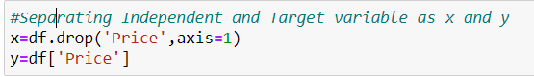

Scaling the dataset:

Feature scaling in machine learning is one of the most important steps during the preprocessing of data before creating a machine learning model. This can make a difference between a weak machine learning model and a strong one.

Feature scaling is essential for machine learning algorithms that calculates distances between data. If not scaled the feature with higher value range will start dominating when calculating distances. And leads taking long time to train a model, A model can be so big and that it’s can’t fit well into the working memory of the training device etc.

Here in this dataset we will apply StandardScaler to normalise the dataset. We will use the code

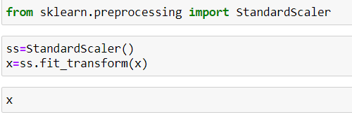

The output is

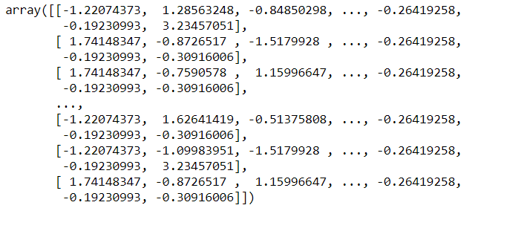

We will do the scaling in **test dataset** also using the following code-

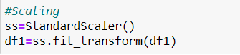

**In this dataset we are using Regression models, since our target variable Price is a continuous variable.**

**Building Machine Learning Models:**

Finding the Best Random State:

First, we will find out the best random state, at that random state r2 score will be maximum. random_state number splits the test and training datasets with a random manner. In addition to that, it is important to remember that random_state value can have significant effect on the quality of your model (by quality I essentially mean accuracy to predict). For instance, If you take a certain dataset and train a regression model with it, without specifying the random_state value, there is the potential that every time, you will get a different accuracy result for your trained model on the test data. So, it is important to find the best random_state value to provide you with the most accurate model.

Here in this dataset we use the below command to find out the best random state-

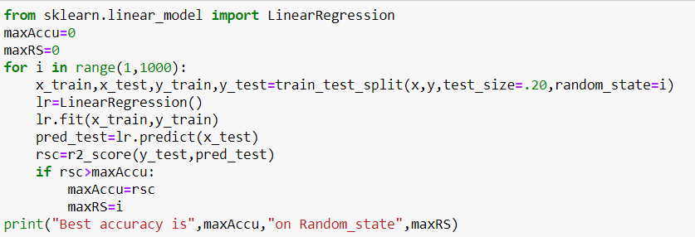



Our best random state is 670 and the accuracy score is 68.93%

**Train Test Split:**

In this step we will split the train and test set and check the dimension of the training and testing set.

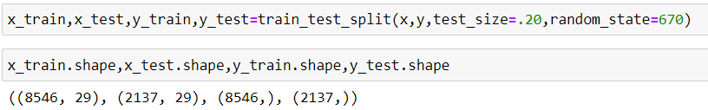

**Building Machine Learning Models:**

The goal in this step is to develop a benchmark model that serves us as a baseline, upon which we will measure the performance of a better and more tuned algorithm. We are using different Regression Technique and comparing them to see which algorithm is giving better performance.

We will now build the machine learning model using different machine learning Regression algorithms that are **Linear Regression, SVR, DecisionTreeRegressor, KNeighborsRegressor, RandomForestRegressor and GradientBoostingRegressor**

Here we use for loop and we get the result in one step. Use the below code to the same.

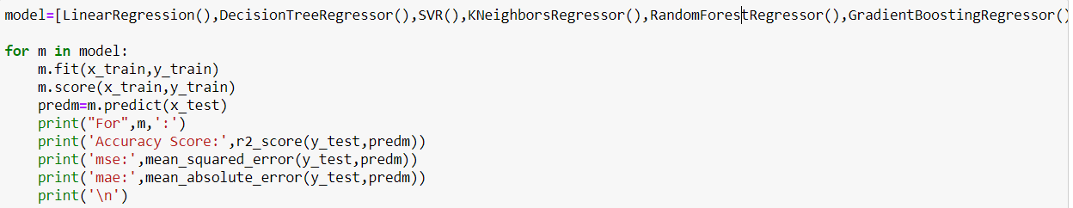

The output is

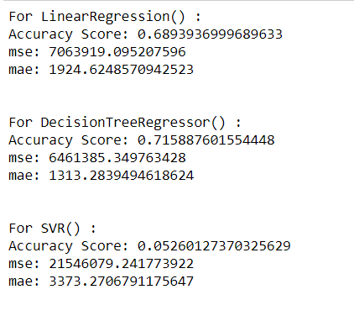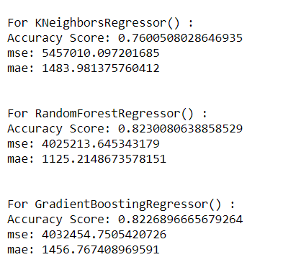

Accuracy score for LinearRegression is 68.93%.

Accuracy score for DecisionTreeRegressor is 71.58%

Accuracy score for SVR 5.2%

Accuracy score for KNeighborsRegressor is 76.00%

Accuracy score for RandomForestRegressor is 82.30%

Accuracy score for GradientBoostingRegressor is 82.26%

**Cross Validation:**

In machine learning, we can’t fit the model on the training data and can’t able to say that the model will work accurately for the real data. For this, we must assure that our model got the correct patterns from the data, and it is not getting up too much noise. For this purpose, we use the cross-validation technique.

Cross-validation is a technique in which we train our model using the subset of the dataset and then evaluate using the complementary subset of the dataset.

Here in this dataset we use the following command to find out the cross validation score.

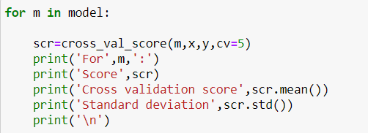

The output is

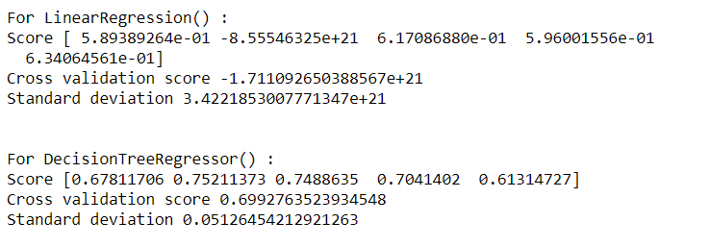

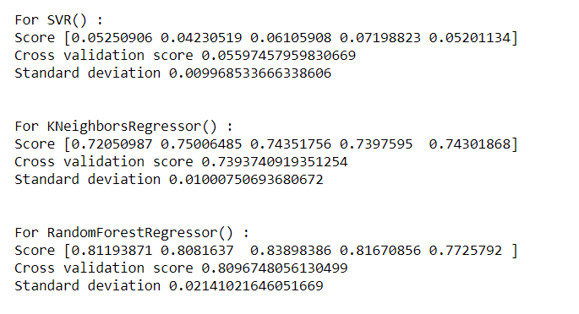

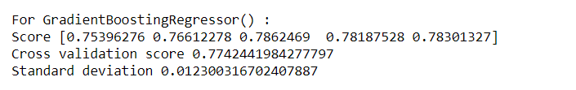

Cross validation score for DecisionTreeRegressor =69.92%

Cross validation score for SVR=5.5%

Cross validation score for KNeighborsRegressor=73.93%

Cross validation score for RandomForestRegressor=80.96%

Cross validation score for GradientBoostingRegressor=77.42%

**Since the difference between the r2_score and cross validation score is minimum for RandomForestRegressor(),**

**this is our best model.**

**Regularization:**

Regularization in machine learning terms is to make things acceptable or regular. The process involves the shrinking of data coefficients to tend to zero values. In other words, the process of regularization of the regularization methods in machine learning will discourage overfitting the model, which then learns to be more flexible in a complex environment.

Here we use the Regularization technique Lasso and we will use the code given below

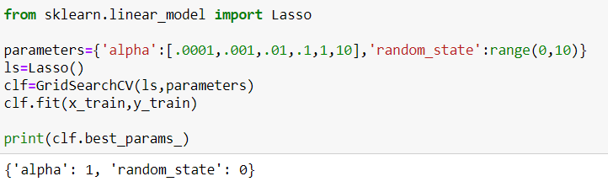

Here we set the parameters list to pass in GridSearchCV. We use the parameters alpha and random_state and find out the best params.

Then we will fit it into the training model and find out the r2 score and code using is

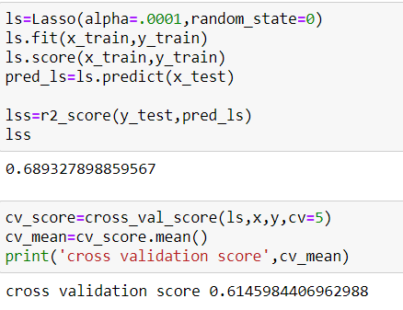

Hyper Parameter Tuning:

A Machine Learning model is defined as a mathematical model with a number of parameters that need to be learned from the data. By training a model with existing data, we are able to fit the model parameters.

However, there is another kind of parameters, known as **Hyperparameters**, that cannot be directly learned from the regular training process. They are usually fixed before the actual training process begins. These parameters express important properties of the model such as its complexity or how fast it should learn.

Usually we are using GridSearchCV for the purpose of tuning.

First we create a parameter list as shown below



Then we will fit it on to training set and finding out best parameters then prediction and finding out the accuracy score.

All these steps are given below.

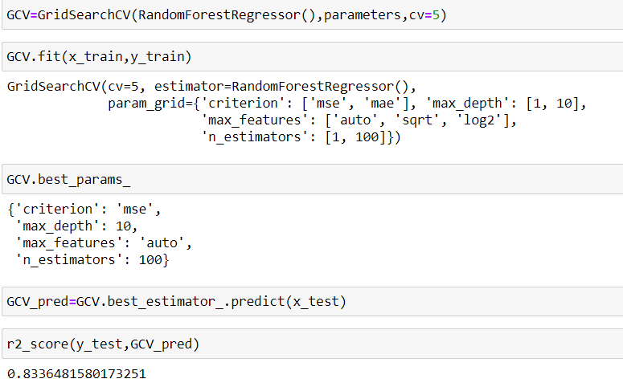

After hyperparameter tuning our accuracy score is 83.36%

**Saving the Model:**

Here in this step we will save our model by importing pickle and using the following code-

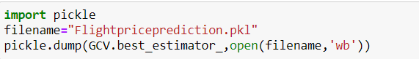

Now we will load the file that we saved and we made prediction over the test data

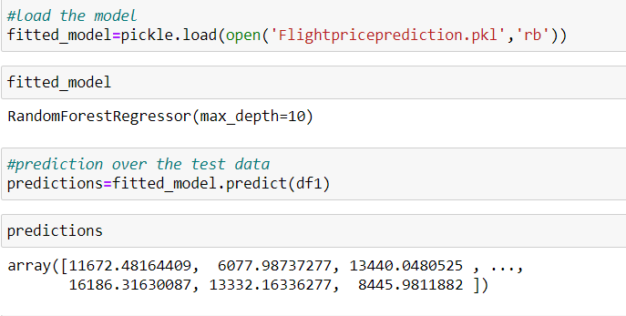

Now we will plot a regression line to check whether it fit properly into the datapoints

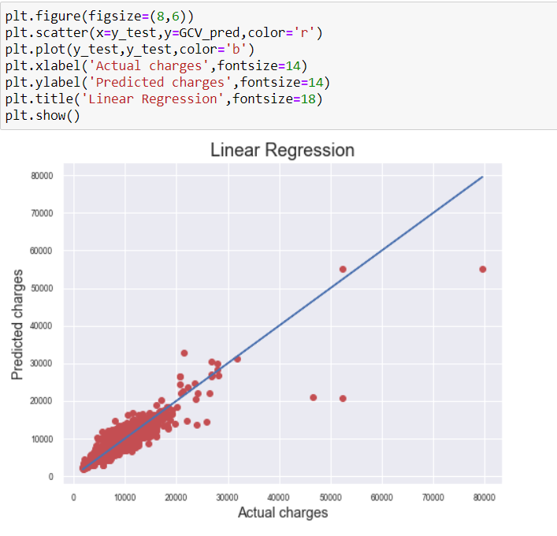

**Concluding Remarks:**

We made the entire journey in a small data science project. We explored the data, cleaned up the data, then we modified features and created new ones and in a last step we made a prediction with a random forest tree classifier.

Here we worked on “Flight price prediction” ,we used train and test set for the prediction.

We have applied regression models on to the data and our best model is Random Forest Regressor.

Our final accuracy score is 83.36%.

Some observations we derived from the dataset are-

* The airline Jet Airways operated the maximum services.
* Delhi is the source for most of the flight services. Cochin is the destination for most of the flight services
* Most of the flight services have only one stop and for many of the cases non-stop.
* Price is high for the airline Jet Airways Business.
* Price is maximum in the month January and minimum in the month April.
* From the data it is clear that most of the flight operations were done in the month May, March and June. among all airways Jet Airways travelled maximum.